Installing pymango:





Worked:

Verify Installation:



Warn Mark:

Payment_Lines sheet:  


So I changed it to add depositDate as part of the _id to make it unique.

New example:

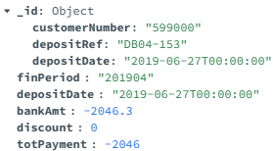

Payment_Header sheet:  




paymentHeaders

Suitability:  Helps with payment tracking, even though it is redundant with paymentLines, having redundancy with anything relating to payments is not potentially bad to have.

So I changed it to add customerNumber as part of the _id to make it unique.

New example:

